Ordering – How to Buy a Single Print or Multiple Prints at Once

Go to the gallery from which you wish to purchase prints or other merchandise.

Ordering Multiple Prints at Once:

Click on the green Buy button.

Select Photos from this Gallery in the drop down list.

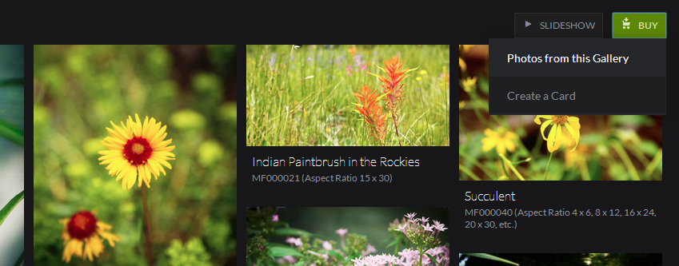

Select the photos you wish to order by clicking on them. Your selected photos will be highlighted with borders, as shown in the next screen print. Then select your Quantity located on the right side of the screen. (Quantity of 1 is automatically specified by default, but you can adjust his value.)

Note, click on SELECT ALL in the upper right corner if you would like to buy all photos in the gallery.

Note, a default size and finish will be automatically chosen and displayed in the upper right section of the screen. Simply click on CHANGE PRODUCT to change it to your desired size and finish.

Note, your current total will also displayed on the right side of the screen.

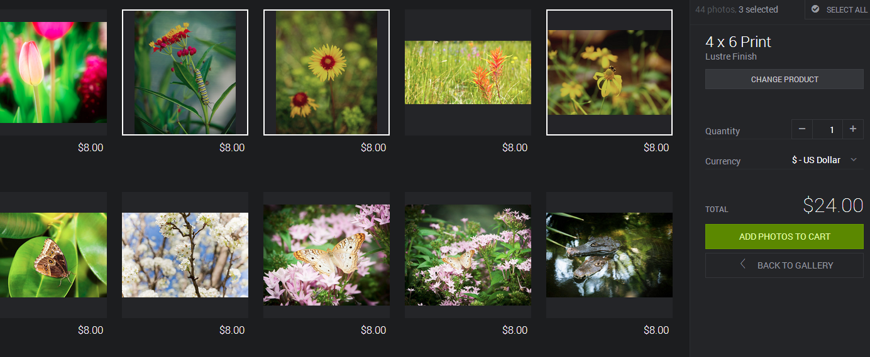
Notice the 3 photos that are highlighted. These have been selected to be printed.
Ordering Just One Print:

Select the photo you want to buy.

You will see a green Buy button. Click on this button.

Select This Photo.

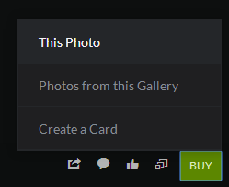

You will see a screen with possibly 3 tabs (Prints, Merchandise and/or Downloads), depending on how the gallery permissions are set for the gallery by its owner. To order prints, make sure you are in the Prints tab.

Note, there are various submenus underneath the Prints tab: Standard Sizes, Panoramic Sizes, Square Sizes, Canvas, ThinWraps and Metal. Learn more about some of these specific products by going to the Products page at www.RFKphoto.com. In addition, many times, there will also be a button you can click within the shopping cart to learn more about the chosen product, as well. (e.g. “VIEW PRODUCT VIDEO”)

Once you have determined the size of your print and the finish (e.g. Lustre, Gloss, Metallic, Giclée Watercolor, Stretched Canvas, etc.), click on the plus (+) icon to add the appropriate number of prints to your cart. Or, you can just type the quantity in the box located between the arrows.

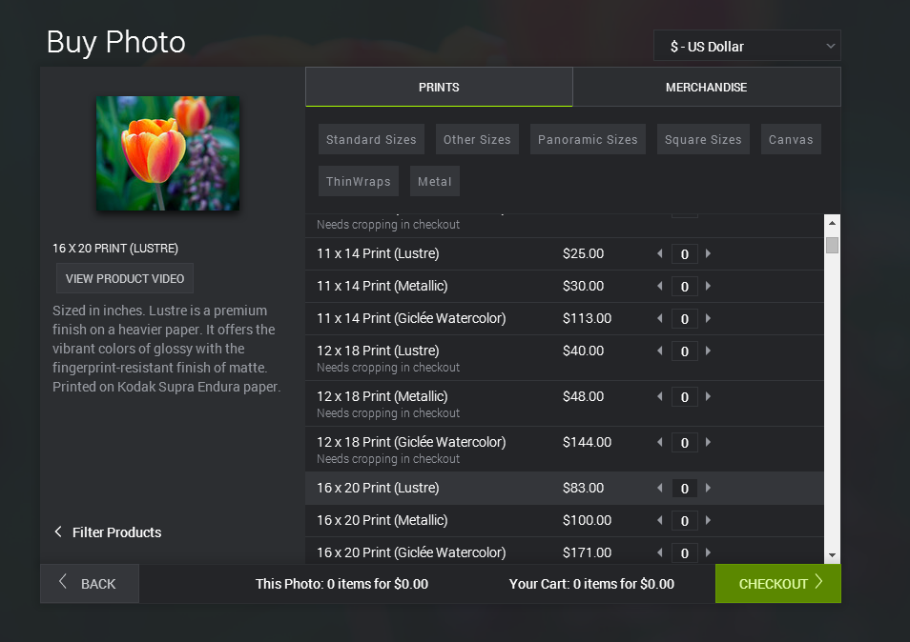
Note, it is possible to select a size that does not match the aspect ratio for the photo you have chosen. If this occurs, you will see crop marks surrounding the photo. The part of the photo that resides within the crop marks is what will be printed. Anything outside of the crop marks will not be printed.

The example in the next screen print illustrates crop marks surrounding the photo. In the example, size 4x6 was chosen; however this photo is formatted for 4x5 aspect ratio. Your choices are as follows:

Option 1: Crop the photo to fit your selected 4x6 size. Note, you can adjust the crop marks at checkout if you are not happy with what has been selected by default.

Option 2: Select None for no cropping at checkout if cropping would not work. For example, cropping may not be an option for a family portrait, as you don’t want Uncle Ned to be cropped out of the photo! Selecting None at checkout will create a white border to meet the selected size requirement. However, none of the photo will be lost. You can later trim the print when you receive it, or you can cover the white borders with a mat.

Option 3: You can simply choose a different size that meets the proper aspect ratio requirement for the photo (e.g. 4x5, 8x10, 16x20, etc.)

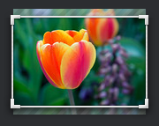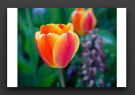
Crop Marks Choosing None creates white border to be printed

Click on the green CHECKOUT button located near the bottom right of the page once you are ready to check out.

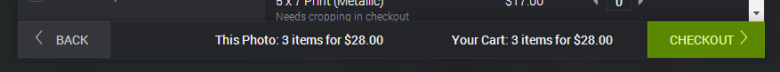

Continued on the next page…

In the next screen, enter a valid coupon code if you have one and click on the Apply button. Then, review your order and make any final changes. You can adjust quantities here. You can also adjust any cropped photos from this page or remove cropping, as well. Once you are finished, click on Checkout.

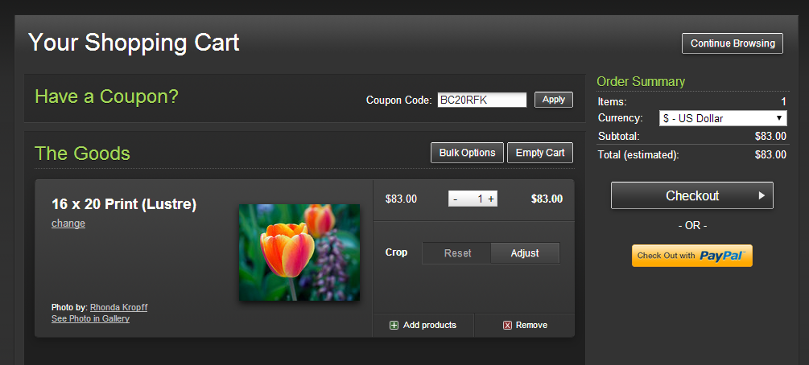

Next, you will be prompted to enter your shipping information. Once completed click on Next: Shipping Options.

Next, you will be prompted to select your shipping option. Once completed, select Next: Payment Info.

Next, you will be prompted to enter your payment information. Select your desired payment method and complete required information. Once completed, click on Next: Review Order.

Review your order. If all is correct, then click on Place My Order. You are done!

Still have questions? Reach out for help via one of the contact options below.

- Fill out the Contact form that is available on the web site. (www.RFKphoto.com)
- Send an email to CustomerService@RFKphoto.com.
- Call Rhonda at 816.665.2242. Leave a message and your call will be returned as soon as possible.

